**Exercise 1: Control Structures**

**Scenario 1:** The bank wants to apply a discount to loan interest rates for customers above 60 years old.

* + **Question:** Write a PL/SQL block that loops through all customers, checks their age, and if they are above 60, apply a 1% discount to their current loan interest rates.

**Scenario 2:** A customer can be promoted to VIP status based on their balance.

* + **Question:** Write a PL/SQL block that iterates through all customers and sets a flag IsVIP to TRUE for those with a balance over $10,000.

**Scenario 3:** The bank wants to send reminders to customers whose loans are due within the next 30 days.

* + **Question:** Write a PL/SQL block that fetches all loans due in the next 30 days and prints a reminder message for each customer.

**Scenario 1**

DECLARE

custID Customers.CustomerID%TYPE;

custDOB Customers.DOB%TYPE;

custAge NUMBER;

BEGIN

FOR cust IN (SELECT CustomerID, DOB FROM Customers) LOOP

SELECT EXTRACT(YEAR FROM SYSDATE) - EXTRACT(YEAR FROM cust.DOB) INTO custAge FROM DUAL;

IF custAge > 60 THEN

UPDATE Loans

SET InterestRate = InterestRate - 1

WHERE CustomerID = cust.CustomerID;

END IF;

END LOOP;

END;

/

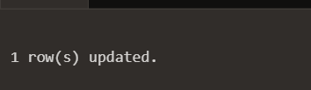

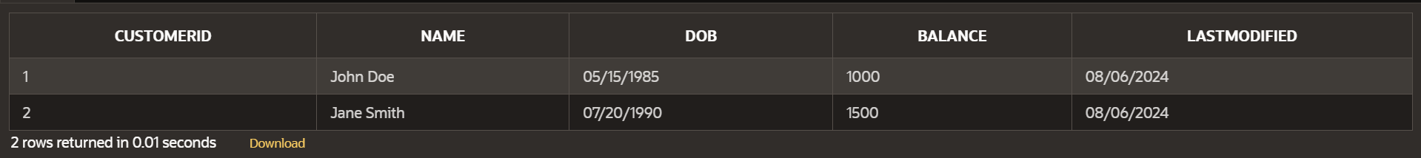



**Scenerio 2**

ALTER TABLE Customers ADD (IsVIP CHAR(1) DEFAULT 'N');

DECLARE

custID Customers.CustomerID%TYPE;

custBalance Customers.Balance%TYPE;

BEGIN

FOR cust IN (SELECT CustomerID, Balance FROM Customers) LOOP

IF cust.Balance > 10000 THEN

UPDATE Customers

SET IsVIP = 'Y'

WHERE CustomerID = cust.CustomerID;

END IF;

END LOOP;

END;

/





**Scenario 3**

SET SERVEROUTPUT ON;

DECLARE

loanID Loans.LoanID%TYPE;

custID Loans.CustomerID%TYPE;

custName Customers.Name%TYPE;

loanEndDate Loans.EndDate%TYPE;

BEGIN

FOR loan IN (SELECT LoanID, CustomerID, EndDate FROM Loans WHERE EndDate <= SYSDATE + 30) LOOP

SELECT Name INTO custName FROM Customers WHERE CustomerID = loan.CustomerID;

DBMS_OUTPUT.PUT_LINE('Reminder: Loan ID ' || loan.LoanID || ' for customer ' || custName || ' is due on ' || TO_CHAR(loan.EndDate, 'YYYY-MM-DD'));

END LOOP;

END;

/

